

Programme Name: ________**BCS HONS**_______________________________________

Course Code: __**CSC 2514**________

Course Name: _______**Web System and Technologies**_____________________________

**Internal Examination**

Date of Submission: ______**8/20/2021**_____________

**Submitted By: Submitted To:**

Student Name**: Dipesh Tha Shrestha** Faculty Name**: Prakash Chandra**

IUKL ID: **041902900028** Department**: LMS**

Semester**: Fourth Semester**

Intake**: September 2019**

1. Explain design consideration for website development

Answer;

As we know, Web development is the process of creating and maintaining a website for the Internet or an intranet that is accessed through a web browser and hosted on a server. design consideration for website development are given below:

Usability

Websites that are easy to use are more likely to garner customer interest and encourage business. Usability can be increased by displaying product and service information in a clear, concise manner. Make sure your website has all the features a customer would need for the site to be easily accessible.

Clean design

Creating a clean, appealing design is one of the most important things to remember during the website development process. A good design is attractive, easy to read, and has simple navigation. Above all, a clean design allows viewers to focus on the value of your brand and content rather than being distracted by distracting graphics and large amounts of text.

Security

With the evolution of technology, newer and more advanced security risks threaten to compromise your website's integrity. From malware and viruses to malicious apps and the threat of hackers, websites must prevent security breaches on both the front ends and back ends. Websites built to conduct online transactions, such as ecommerce sites, need additional security measures to protect customer information.

Navigation

Customers may leave and never return if your website is confusing and difficult to navigate. Conduct an in-depth site review as if you were a new visitor to improve the efficiency and appeal of your site's navigation.

Compatibility with a Wide Range of Browsers

The number of internet browsers is steadily increasing as technology advances. It's difficult to keep up with all of them, from Internet Explorer and Chrome to Firefox and Safari. When building a website, it's critical to make sure that it's accessible from a variety of browsers. Your website, in particular, should work in all major browsers, including older versions.

1. Write HTML and required PHP code to generate output as shown below:
2. <!DOCTYPE html>
3. <html lang="en">
4. <head>
5. <meta charset="UTF-8">
6. <meta http-equiv="X-UA-Compatible" content="IE=edge">
7. <meta name="viewport" content="width=device-width, initial-scale=1.0">
8. <title>percentage</title>
9. </head>
10. <body>
11. <?php
12. if($_SERVER['REQUEST_METHOD']=='POST')
13. {
14. $num = $_POST['num'];
15. echo "<h3> Result obtained: </h3>";
17. if($num>70){
18. echo"DISTINCTION";
19. }
20. elseif($num<60 && $num>69){
21. echo "FIRST DIVISION";
22. }
23. elseif($num>50 && $num <59){
24. echo "SECOND DIVISION";
25. }
26. else{
27. echo"FAIL";
28. }
29. }
30. ?>
31. <form action="<?php htmlspecialchars($_SERVER['PHP_SELF']);?>" method="POST">
32. <fieldset style="width: 30%;">
33. <p>Enter percentage of marks obtained</p>
34. <input type="number" name="num"><br>
35. <input type="submit">
36. </fieldset>
37. </form>
38. </body>
39. </html>

Output:

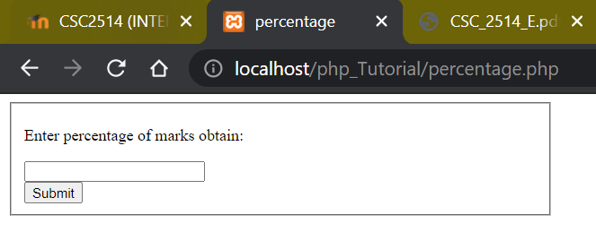

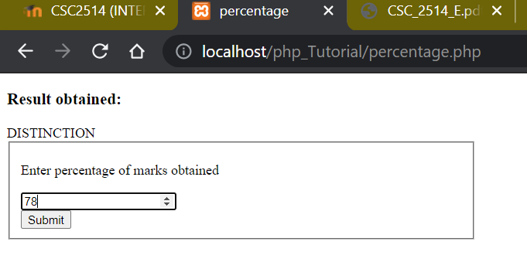

1. Write HTML and required PHP code to generate output as shown below:

<!DOCTYPE html>

<html lang="en">

<head>

    <meta charset="UTF-8">

    <meta http-equiv="X-UA-Compatible" content="IE=edge">

    <meta name="viewport" content="width=device-width, initial-scale=1.0">

    <title>Product</title>

</head>

<body>

   <div>

  <fieldset style="width: 30%;">

  <label for "Product">Product</label>

<input type="text" name="Product"><br><br>

<label for "Name">Name:</label>

<input type="text" name="Name"><br><br>

<lable for="myfile">Photo</label>

<input type="file" id="myfile" name="myfile">

<br>

<br>

<button type="submit" class="submit">submit</button>

</form>

  </fieldset>

</div>

<?php

include_once 'dsiplay.php';

if(isset($_POST['submit']))

{

    $Product = $_POST['Product'];

    $Name= $_POST['Name'];

    $myfile= $_POST['Photo'];

    $sql = "INSERT INTO details (Product, Name, Photo)

    VALUES ('$Product','$Name','$Photo')";

    if (mysqli_query($conn, $sql)) {

       echo "New record has been added successfully !";

    } else {

       echo "Error: " . $sql . ":-" . mysqli_error($conn);

    }

    mysqli_close($conn);

}

?>

</body>

</html>

Output:

